CS 255 System Design Document Template

UML Diagrams

UML Use Case Diagram
The use case diagram illustrates how different users interact with the DriverPass system. Customers can schedule driving lessons, make payments, and view their lesson schedules. Employees are responsible for managing lesson schedules and assigning drivers and vehicles. IT Officers support the system by performing administrative tasks such as resetting user passwords. This design ensures that each user role has access only to the features necessary to perform their responsibilities, supporting both usability and security requirements.

UML Activity Diagrams
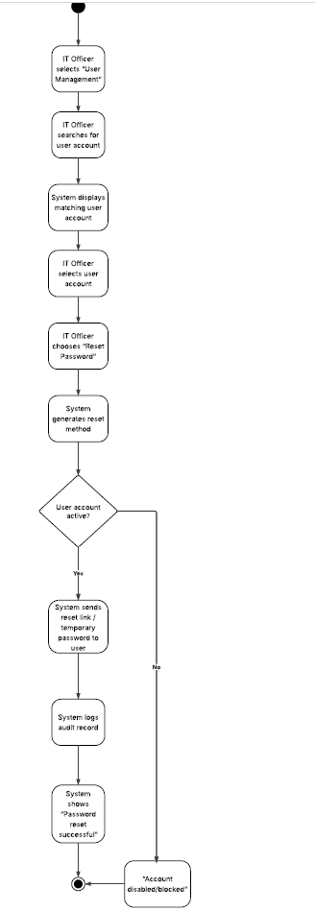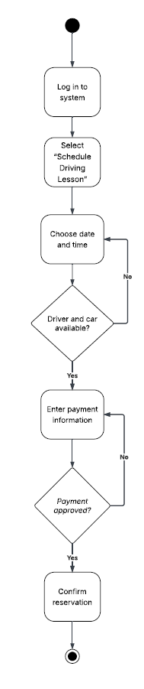
The activity diagrams show the step-by-step workflows for key system processes. The “Schedule Driving Lesson” activity diagram demonstrates how a customer logs in, selects a date and time, checks driver and vehicle availability, submits payment information, and confirms a reservation. Decision points ensure that lessons are only scheduled when resources are available and payment is approved.
The “Reset User Password” activity diagram illustrates the process followed by an IT Officer to locate a user account, verify account status, generate a reset method, and log the action for auditing purposes. These workflows ensure consistency, accuracy, and accountability within the system.

UML Sequence Diagram
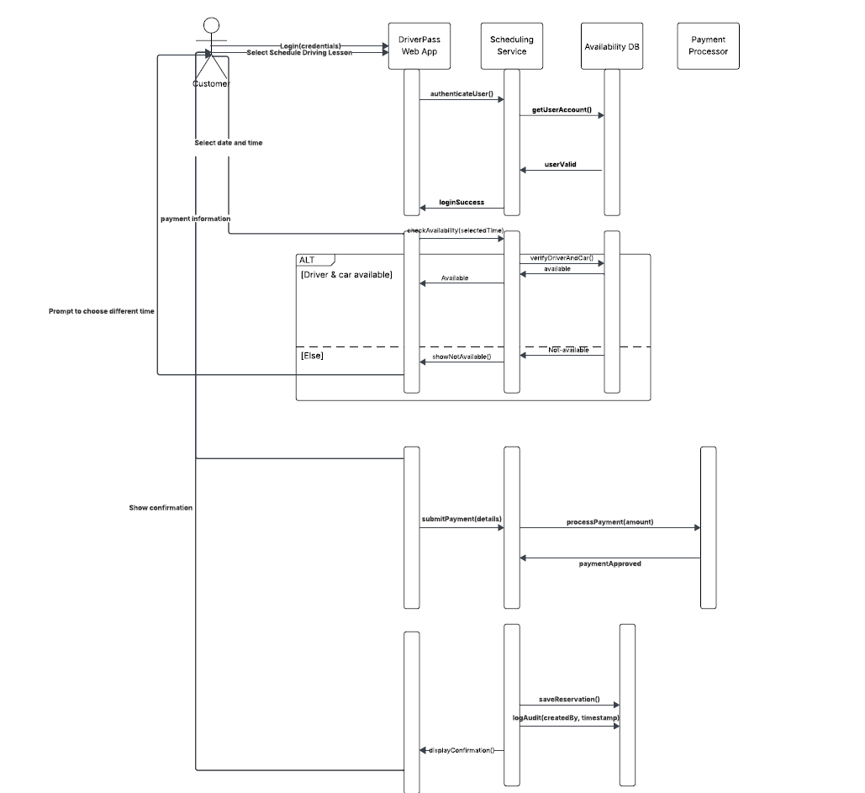

The sequence diagram represents the interaction between the customer, the DriverPass web application, backend services, and external systems during the lesson scheduling process. It shows how the system authenticates the user, checks driver and vehicle availability, processes payment through a third-party service, saves the reservation, and displays confirmation to the customer. This diagram highlights the order of communication between system components and ensures that all required steps occur in the correct sequence.

UML Class Diagram
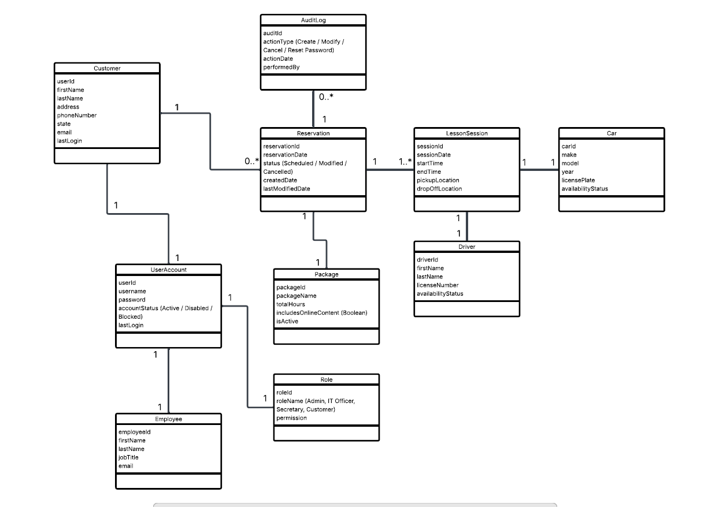

The class diagram defines the main data structures used in the DriverPass system. Key classes include UserAccount, Customer, Employee, Reservation, LessonSession, Driver, Car, Role, Package, and AuditLog. Each class contains attributes that represent essential system data, such as user information, lesson details, and availability status. The relationships between classes illustrate how customers schedule lessons, how reservations are linked to drivers and vehicles, and how system actions are tracked. This design supports efficient data organization and system scalability.

Technical Requirements
Hardware Requirements
The DriverPass system will be accessed using standard devices such as desktop computers, laptops, tablets, and smartphones. These devices must support modern web browsers and reliable internet connectivity. The system will be hosted on a secure server or cloud-based environment capable of handling concurrent users and storing system data.
Software Requirements
The system will be implemented as a web-based application to allow easy access for customers and staff. A database management system will be used to store customer information, lesson schedules, driver and vehicle availability, and audit logs. The system will integrate with a third-party payment processor to securely handle online payments. Administrative tools will be provided for employees and IT officers to manage users and schedules.
Security Requirements
Security is a critical requirement for the DriverPass system. All users must authenticate using secure login credentials. Role-based access control ensures that customers, employees, and IT officers can only access authorized features. Sensitive customer and payment data will be protected using secure transmission and storage methods. System actions such as scheduling changes and password resets will be logged for auditing and accountability.
Infrastructure Requirements
The system requires a stable internet connection to support online scheduling and payment processing. It must be available during business hours to meet customer needs. Regular system monitoring and data backups will be implemented to maintain reliability and reduce downtime.

